**“Attendance Monitoring System using Facial Recognition**.**”**

**Mrs. Y. U. Kadam**

**Department of Computer Technology**

**K. K. Wagh Polytechnic, Nashik, India**

|  |  |  |  |  |
| --- | --- | --- | --- | --- |
| **Aditya M. Suryawanshi** |  |  |  | **Sejal P. Pathak** |
| **Department of Computer Technology** |  |  |  | **Department of Computer Technology** |
| **K. K. Wagh Polytechnic, Nashik, India** |  |  |  | **K. K. WagK.K Wagh Polytechnic, Nashik, India India** |
| **Sakina M. Modi** |  |  |  |
| **Department of Computer Technology** |  |  |  |
| **K. K. Wagh Polytechnic, Nashik, India** |  |  |  |

------------------------------------------------------------------***------------------------------------------------------------

**Abstract -** Efficient and reliable attendance monitoring remains crucial in today's educational landscape, facing new challenges alongside traditional concerns. Existing methods, like roll calls and paper-based systems, prove time-consuming and inefficient. To address these limitations and promote environmental sustainability, we propose an "Attendance Monitoring System using Facial Recognition" developed with Tkinter.This innovative application levecrages facial identification technology to streamline the attendance process. It not only enhances efficiency but also contributes to environmental responsibility by minimizing paper usage. Furthermore, the system incorporates facial recognition as a biometric authentication method, combating the issue of attendance manipulation. This technology is particularly well-suited for educational institutions where accurate attendance data is essential. This project represents a significant advancement in attendance management, bridging the gap between technological innovation and educational needs. By automating the process and ensuring accuracy, this system has the potential to positively impact the educational landscape.

***keywords****:*

1. *Python 3.8*
2. *MySQL*
3. *Tkinter*

# Introduction

The Attendance System using Face – Recognition is a replacement way method for the traditional way of marking attendance. The proposed system is Desktop application, Machine Learning based system.. This system can be implemented on a single faculty system of a particular institute. This system is proposed to be based on biometrics .i.e. Face Authentication. Since there is presence of biometrics, this system completely eliminates the chances of fake attendance which is a problem with the traditional methods of attendance.

The Attendance management is the significant process that were carry out in every institute to monitor the performance of the student. Every institute does this in its own way. Some of there institute use the old paper or file-based system and some have adopted strategies of automated attendance system using some biometric technique. A facial recognition system is a computerized software which is suited for determining or validating a person by performing comparisons on patterns based on their facial appearances.

Here, the teacher will be the super user (Administrator). Teacher will be able to manage the data of the students stored in the database. Data includes attendance, performance in practicals, rating of student,etc. After the completion of theory sessions the teacher would just scan multiple students and assign the attendance of present students in just one tap! Administrator would also be able to scan the face of a particular student and read its data.

# Literature Survey

Using real time computer vision algorithms in automatic attendance management systems This system introduces a new approach in automatic attendance management systems, extended with computer vision algorithms. The Proposed system uses real time face detection algorithms.

Automatic Control of students’ attendance in Classrooms Using RFID Radio frequency identification (RFID) is one of the automatic identification technologies more in vogue nowadays. There is a wide research and development in this area trying to take maximum advantage of this technology, and in coming years many new applications and research areas will continue to appear.

Face Recognition based Attendance Management System using Machine Learning is the most arduous task in any organization is attendance marking. We proposed an automated attendance management system which tackles the predicament of recognition of faces in biometric systems subject to different real time scenarios such as illumination, rotation and scaling.

Face Recognition-based Lecture Attendance System proposed a system that takes the attendance of students for classroom lecture. The system takes attendance automatically using face recognition. However, it is difficult to estimate the attendance precisely using each result of face recognition independently because the face detection rate is not sufficiently high.

# Problem Definition

Educational institutions struggle with time-consuming and inaccurate attendance methods like roll call and paper signatures. These practices waste faculty time, lead to unreliable data, and harm the environment with paper usage. To address these problems, we propose an "Attendance Monitoring System Using Facial Recognition". This application automates attendance marking by capturing student faces, comparing them to a database using facial recognition, and automatically marking attendance. This not only saves time and resources but also improves accuracy and security, making it a leap forward in attendance management and a significant contribution to the educational landscape.

# Proposed Working



The proposed working for the project “Attendance monitoring system using facial recognition” is likely for an attendance marking application. It starts by loading an image, potentially from a database. The system then determines if a face is present. If a face is detected, it is cropped and sent to a database for training or recognition. If no face is detected, the system might record the student as absent. This process suggests that the system is designed to automatically mark attendance based on facial recognition, potentially improving efficiency and accuracy compared to traditional methods.

# Result

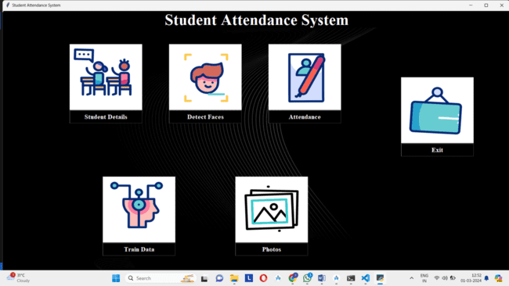

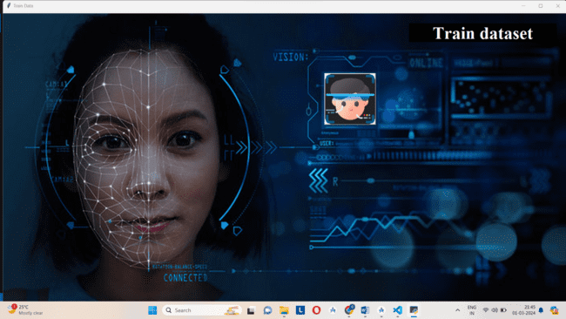

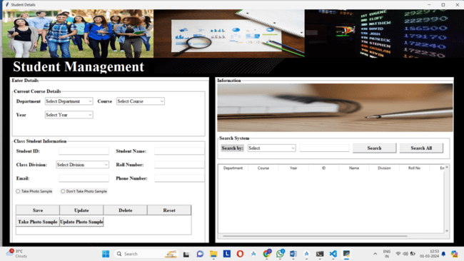

# Conclusion

The "Attendance Monitoring System using Facial Recognition" project presents an innovative and efficient solution to the perennial challenges faced by educational institutions when it comes to monitoring and recording student attendance. By leveraging cutting-edge technology and machine learning capabilities, this system not only streamlines attendance tracking but also enhances security and reduces environmental impact.

Through our feasibility analysis, we have determined that this project is both technically and economically feasible. The benefits of implementing this system include improved accuracy, reduced administrative workload, and a positive impact on the environment by minimizing paper usage.

It’s important to emphasize that the successful development and implementation of this system will significantly contribute to educational institutions' operational efficiency and effectiveness. It aligns with the ever-evolving educational landscape, providing a robust solution to the persistent issue of attendance management.

**10. References**

[1]. Dipti Kumbhar , Prof. Dr. Y. S. Angal Department of Electronics and Telecommunication, Smart Attendance System using Computer Vision and Machine Learning yogeshangal@yahoo.co.in IRJET 1/4/2022]

[2]. P. Visalakshi, Sushant Ashish Assistant Professor ,Department of Computer Science and Engineering SRM Institute of Science and Technology, Chennai, Tamil Nadu, ATTENDANCE SYSTEM USING MULTI-FACE RECOGNITION , IEEE 27/5/2023]

[3]. CH. VINOD KUMAR , DR. K. RAJA KUMAR PG Scholar, Dept of CS& SE, Andhra University, Vishakhapatnam, AP, India. Assistant Professor, Dept of CS& SE, Andhra University, Vishakhapatnam, AP, India. Face Recognition Based Student Attendance System with OpenCV 15/12/2022]

[4]. Face Recognition based Attendance Management System using Machine Learning. IRJET 06, June 2022 ]

[5]. Ashish Choudhary,Abhishek Tripathi,Abhishek Bajaj,Mudit Rathi and B.M Nandini Information Science and Engineering, The National Institute of Engineering, Automatic Attendance System Using Face Recognition. IRJET 12/5/2021]

[6]. Anushka Waingankar1, Akash Upadhyay, Ruchi Shah, Nevil Pooniwala, Prashant Kasambe. Face Recognition based Attendance Management System using Machine Learning IEEE 8/6/2023]